1. Environment Overview: AWS Elastic Beanstalk (PaaS)
For the final project, AWS Elastic Beanstalk was selected as the core deployment platform. As a Platform as a Service (PaaS) solution, it provides an orchestrated environment that streamlines the deployment process while maintaining high availability and security.

Technical Implementation Details
Elastic Beanstalk was configured to automate and manage the following infrastructure components:
- Compute: Provisioning of Amazon EC2 instances tailored for the application workload.
- Runtime Environment: Fully managed execution environment using Python 3.13.
- Database Integration: Seamless connectivity with Amazon RDS (PostgreSQL), ensuring data persistence and managed backups.
- Traffic Management: Deployment of an Application Load Balancer (ALB) to efficiently distribute incoming traffic across multiple instances.
- Elasticity: Integrated Auto Scaling group that adjusts capacity based on real-time Amazon CloudWatch metrics.
- Observability: Comprehensive logging and health monitoring via Amazon CloudWatch logs and dashboards.

2. Technology Rationale & Architectural Decisions
The selection of the AWS stack for this project was driven by the need for a balance between rapid deployment, high availability, and robust security. Below is the justification for the core technologies implemented.

Why AWS Elastic Beanstalk (PaaS)?
While manual EC2 management offers maximum control, Elastic Beanstalk was chosen for its operational efficiency:
- Deployment Simplicity: Enables a streamlined "Code-to-Cloud" workflow where a single application archive triggers a full environment orchestration.
- Deep AWS Ecosystem Integration: Out-of-the-box compatibility with Amazon RDS, CloudWatch, and IAM, ensuring that all components communicate securely and efficiently.
- Managed Scalability: Automates the complexity of scaling and updates, reducing the risk of downtime during traffic spikes or version transitions.
- Reduced Operational Overhead: Eliminates the need for manual patching and server provisioning, allowing focus on application-level security and logic.

Security and Scalability Framework
The environment was architected with a "Security First" mindset, adhering to the following principles:
- Network Isolation: Deployment within a custom Amazon VPC, utilizing private subnets for sensitive resources (like RDS) to prevent direct internet exposure.
- Granular Access Control: Implementation of IAM Roles and Security Groups to enforce the Principle of Least Privilege (PoLP), ensuring only necessary traffic and permissions are allowed.
- High Availability: The combination of an Application Load Balancer (ALB) and Auto Scaling ensures the application can adapt to load changes while maintaining a high uptime SLA.

Educational Note: The Advantage of PaaS in Cybersecurity
From a cybersecurity perspective, using a managed service like Elastic Beanstalk reduces the attack surface. By offloading the management of the underlying OS and runtime patches to AWS, the risk of vulnerabilities arising from unpatched infrastructure is significantly mitigated.

3. Solution Architecture
The following diagram illustrates the cloud infrastructure designed for this application. It represents a highly available, secure, and scalable web environment within the AWS ecosystem.

Architectural Flow & Components
- Entry Point: The User accesses the application via the public internet, where requests are first handled by the AWS Cloud boundary.
- Virtual Private Cloud (VPC): All compute resources are isolated within a dedicated VPC, providing a logical network perimeter.
- Traffic Distribution (ELB): An Elastic Load Balancer acts as the single point of contact. It intelligently routes incoming traffic to healthy EC2 instances across multiple Availability Zones, preventing any single point of failure.
- Connectivity (Internet Gateway): The Internet Gateway (IGW) allows communication between the VPC and the internet, enabling the Load Balancer to receive external requests.
- Compute Layer: The application runs on EC2 instances managed by Elastic Beanstalk. These instances are organized in a cluster to ensure workload distribution.
- Operational Intelligence:
  - Amazon CloudWatch: Continuously monitors system health, performance metrics, and logs.
  - AWS Auto Scaling: Dynamically adjusts the number of EC2 instances based on CloudWatch alarms, ensuring the application stays responsive during traffic spikes and cost-effective during low demand.
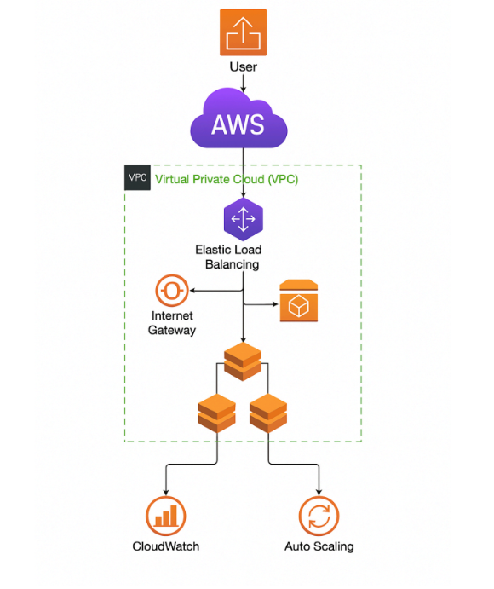

4. Deployment and Configuration Guide
This section outlines the end-to-end process of deploying the Flask application to AWS Elastic Beanstalk, including database integration, security hardening, and monitoring setup.

Phase 1: Application Source Preparation
Before deployment, the application environment was standardized to ensure compatibility with AWS Linux 2023:
- Core Logic: Developed a Flask application (application.py) with SQLAlchemy for ORM-based interaction with PostgreSQL.
- Dependency Management: Generated a requirements.txt file to ensure a consistent runtime environment.
- Process Management: Created a Procfile to instruct Elastic Beanstalk on how to launch the application using the Gunicorn WSGI server:
Makefile
web: gunicorn application:app
- Artifact Creation: All essential files were bundled into a high-integrity ZIP archive for deployment.

Phase 2: Orchestrating the Environment
The deployment was executed through the AWS Management Console with the following specifications:
- Environment Type: Web Server Environment.
- Platform Stack: Python 3.13 running on Amazon Linux 2023.
- Deployment Method: Manual upload of the prepared ZIP artifact.

Phase 3: Secure Database Integration (RDS)
To ensure data persistence and security, an Amazon RDS (PostgreSQL) instance was provisioned:
- Network Security: Configured Security Groups to allow inbound traffic only from the Elastic Beanstalk instances (limiting the attack surface).
- Environment Secrets: Instead of hardcoding credentials, sensitive data (DB_HOST, DB_USER, DB_PASSWORD) was injected via Elastic Beanstalk Environment Properties.
- Code Integration: The application retrieves these credentials securely using os.environ for database URI construction.

Phase 4: Security Architecture & IAM
Adhering to the Principle of Least Privilege (PoLP) and network segmentation:
- VPC Design: Implemented a multi-tier architecture where the Elastic Beanstalk environment resides in public subnets, while the RDS Database is isolated in private subnets.
- IAM Roles: Created a dedicated EC2 Instance Profile (IAM Role) that grants the minimum necessary permissions for instances to communicate with RDS and push logs to CloudWatch.

Phase 5: Monitoring, Scalability, and High Availability
The infrastructure is designed to be self-healing and observable:
- Observability: Integrated Amazon CloudWatch to track CPUUtilization and EnvironmentHealth.
- Alerting: Configured a CloudWatch Alarm integrated with Amazon SNS to trigger notifications if CPU load exceeds 80%.
- Elasticity: Configured Auto Scaling with a dynamic range (Min: 1, Max: 4 instances) based on real-time traffic demands.
- Load Balancing: Deployment of an Application Load Balancer (ALB) to distribute traffic and perform health checks on the underlying fleet.

5. Implementation Evidence & Monitoring
This section provides visual confirmation of the successfully deployed infrastructure, its operational health, and the security/cost controls implemented.

5.1 Deployment & Connectivity
- Application Environment: The Elastic Beanstalk dashboard confirms the environment Flask-app-env is in a Green (Healthy) state, running on Python 3.11/Amazon Linux 2023.
- Database Connectivity: A successful browser test confirms that the application is correctly interfaced with the Amazon RDS (PostgreSQL 17.2) instance, retrieving version information via SQLAlchemy.
- Infrastructure: The Application Load Balancer (ALB) is active and correctly mapping traffic across multiple availability zones.
Environment Dashboard confirming health and platform version.
Live application URL showing successful handshake with the RDS instance.

5.2 Scalability & Monitoring
- Auto Scaling Configuration: The system is configured for high availability with a dynamic instance range (1 to 3 instances) and an automated scale-up trigger when CPUUtilization reaches 80%.
- CloudWatch Alarms: A custom alarm (flask-alarm) is active, monitoring the fleet's CPU usage.
- Proactive Notifications: Integrated Amazon SNS topic (Default_CloudWatch_Alarms_Topic) ensures that any system stress triggers an immediate email alert to the administrator.
Visual monitoring of CPU metrics with an active threshold alarm.
SNS Subscription confirmed for real-time security and performance alerts.

5.3 Cost Optimization (AWS Budgets)
To ensure fiscal responsibility and prevent "cloud sprawl," AWS Budgets has been implemented:
- Monthly Budget: Set at a strict $5.00 threshold.
- Tiered Alerting: Three distinct alerts are configured:
  - 85% of Actual Costs: Early warning of budget approach.
  - 100% of Forecasted Costs: Predictive alert based on usage patterns.
  - 100% of Actual Costs: Critical notification when the limit is reached.
Budget dashboard showing cost tracking and threshold status.

5.4 Advanced Monitoring & Incident Response
To demonstrate the practical application of AWS monitoring tools, a stress test was simulated, triggering the configured security and performance protocols.
- Real-time Incident Detection: The CPUUtilization alarm transitioned to the ALM (In alarm) state as traffic exceeded the 80% threshold.
- Visualizing Performance: The CloudWatch metrics graph clearly shows the upward trend in resource consumption, confirming that the monitoring system accurately reflects the environment's real-time state.
- Automated Notification Loop: A critical component of this setup is the AWS SNS (Simple Notification Service) integration. Upon the alarm trigger, an automated email notification was successfully dispatched to the administrator.
Active alert state in the CloudWatch dashboard during a performance peak.
Granular metric view showing the exact moment the threshold was crossed.
Evidence of the SNS-generated email alert, detailing the specific instance and metric that triggered the incident.

5.5 Granular Cost Management
The implementation of AWS Budgets includes precise thresholds to avoid unexpected billing:
- Actual vs. Forecasted: The system monitors both current spending and predictive trends, ensuring 360-degree financial visibility.
- Multi-Tier Alerts: Configured alerts at 85% and 100% of the budget provide a tiered response strategy for cost control.
Detailed breakdown of the active budget alerts and their current thresholds.

